

ITA0330-Mobile Computing
Name: -G. Akshya Reg no: -192425132
Slot: -D Course Name: -Mobile Computing

Experiment 12: Operation of General Packet Radio Service Using Figma

Aim

To develop a flowchart in Figma explaining the operation of General Packet Radio Service (GPRS) in a mobile communication system.

Procedure

- Open Figma and create a new design frame.
- Add the heading Operation of GPRS at the top.
- Draw an oval and label it “Start”.
- Add a process box for the mobile user requesting a data service.
- Add boxes showing the mobile station sending a request to the Base Transceiver Station (BTS).
- Connect the BTS to the Base Station Controller (BSC).
- Add the Serving GPRS Support Node (SGSN) to manage packet delivery and mobility.
- Connect the SGSN to the Gateway GPRS Support Node (GGSN).
- Add a box for connecting to the Internet or an external packet data network.
- Draw arrows between all components to show the direction of packet transmission.
- Apply light colours and arrange the shapes neatly.
- Preview the flowchart and check that all labels and connections are clear.

Output: -
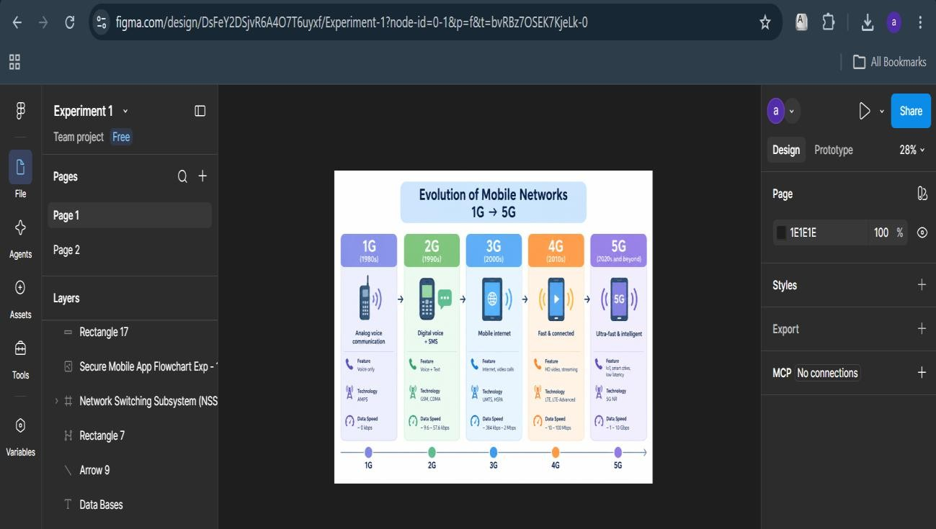

https://www.figma.com/design/DsFeY2DSjvR6A4O7T6uyxf/Experiment-1?node-id=0-1&p=f&t=bvRBz7OSEK7KjeLk-0

Result: -The GPRS operation flowchart was successfully designed in Figma. It illustrates how mobile data travels through the BTS, BSC, SGSN, and GGSN to reach an external packet data network. The flowchart provides a clear understanding of packet-switched mobile communication.

